**SMART COVID-19 PRECAUTION DEVICE**

1**) Titile of the Project :** SMART COVID-19 PRECAUTION DEVICE

2) **Description :** This project gives us information about to take precaution towards Covid-19 Out break.The Project or Device contain two main components /sensor **1)Ultrasonic sensor** and **2)Temperature sensor.**

The Ultasonic sensor is placed Beside the door of our home ,if any person is crosses that Utrasonic sensor , It detect and immediately sends a Whatsapp message to our mobile phones i.e

“ **ALERT!!!!!!!! Someone is outside your door. Please tell him to clean his hands with sanitizer kept there and touch the temperature sensor** ”.

when ower see the message he has to tell the person to touch the temperature sensor and check his/her **body temperature.** If the person body temperature is more then the normal body temperature

Then one more Whatsapp message is sent to owner regarding his temperature measurement i.e

“**ALERT!!!!!!!!** **The person`s body temperature is not normal He has Fever**

**TEMPERATURE =** xx.xx**`F** “.

Now the owner has to take few precaution measure like **wearing mask ,washing hands often ,using sanitizer,social distancing** etc. The person may affected or may not be, but we need to take precaution everytime.

Hence this device helps us to detect the temperature of preson (regarding he/she is well or unwell) and we can take precaution in advance.

The **Covid-19** is very dangerous and viral infection so we need to take precaution in advance like social distancing ,wearing mask etc .

**3) Hardware And Software requirements:**

Hardware requirements:

1) Arduino UNO

2) Ultrasonic sensor

3) LM35 Temperature sensor

4) Bread board

5) Few Jumpper Wires

Software Requirements:

1) Arduino IDE ( to run / dump Arduino code )

2) Anaconda Spyder or any other python Compiler ( to run python code )

3) Twilio Website (account created and setup)

Install Twilio in your Python IDE

* pip install twilio

4) Whatsapp messenger

**4)Process Flow**

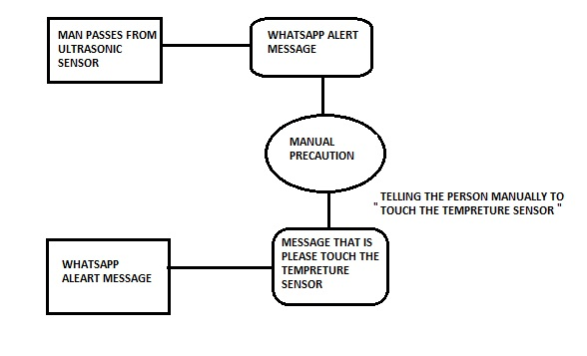

The “ PROCESS FLOW “ of the project is given above ,and its illustrate in steps, the steps are as follows

**Step1** : when any person pass infront of the ultra-sonic sensor

**Step2** : the user will get Whatsapp message that “ **ALERT!!!!!!!! Someone is outside your door. Please tell him to clean his hands with sanitizer kept there and touch the temperature sensor** ”.

**Step3** : By manually telling to “touch the temperature sensor”

**Step4** : If that person`s temperature is not normal Then owner gets next alert message as “**ALERT!!!!!!!!** **The person`s body temperature is not normal He has Fever**

**TEMPERATURE =** xx.xx**`F** “.

**5)Data Flow:**

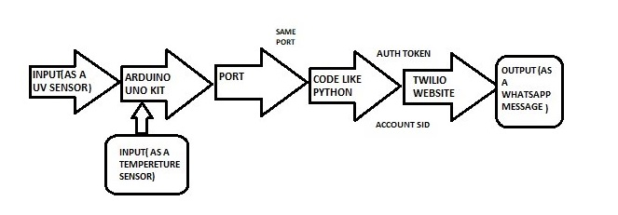

The “ DATA FLOW “ of the project is given above ,and its illustrate in steps, the steps are as follows.

**Step 1)** The Ultrasonic sensor acts as first input to the arduino which then processes the input according to the arduino code and gives output to port.

**Step 2)** The temperature sensor all takes temperature interms of input and according to the the arduino code output is given to port.

**Step3)** The python code gets the ouput of each sensor and gives the result to the ACCOUNT SID and AUTH TOKEN i.e Twilio account by API METHOD

**Step 4)** Then From the Twilio website /account output is send to the Whatsapp Number added in that Account.

**Step 5)** According to the Whatsapp message we can take precautions .